Mocha

Stereo vision module with patterned IR illumination and depth engine

**CONFIDENTIAL**

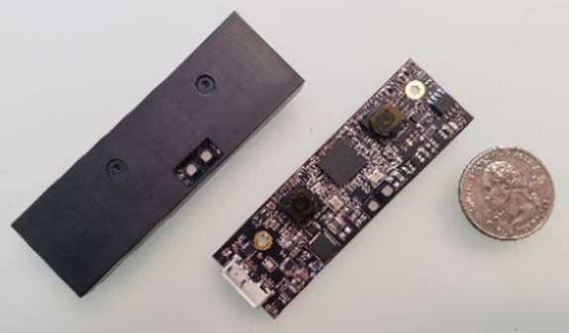

|  |  |  |
| --- | --- | --- |
| Product Description  Mocha is a stereo vision module with 2 IR sensitive color cameras, a patterned IR illumination to assist with depth map computation, and a depth computation ASIC on-board.  Mocha comes pre-calibrated for optimal stereo. The module comes in a metal housing for optimal mechanical ruggedness and thermal management.  Mocha provides flexibility over range from 15cm up to 3m.  Mocha utilizes Heptagon’s proprietary patterned IR projector for texture projection to enable fast and efficient stereo matching and depth map generation.  The dedicated depth engine enables fast and efficient computation of depth map out of the stereo camera pair. | |  |
| Features   * Robust active stereo, powered by Heptagon’s unique IR pattern projector * Pre-calibrated stereo module * Depth engine for fast and power efficient depth map generation * USB3.0 connector |

Applications

* Mobile devices
  + Enhanced photography
  + Gesture recognition
* Virtual reality & augmented reality platforms
  + Gesture recognition
  + Obstacle recognition
  + SLAM
* 3D camera modules for PCs, tablets, and laptops
  + Background removal
  + 3D scanning
* Smart home devices with 3D vision
  + Surveillance
  + Human tracking
* Robots & drones
  + 3D vision
  + SLAM, obstacle recognition
* Health & medical
* Automotive

Specifications

|  |  |  |
| --- | --- | --- |
| **Component** | **Parameter** | **Specification** |
| **Stereo camera** | Number of pixels | 1.2MP |
|  | Frame rate | 30fps |
|  | Pixel size | 3µm |
|  | Diagonal field of view | 71.5 degrees |
| **IR pattern projector** | Wavelength | 850nm ±10nm |
|  | Number of features | >10,000 |
|  | Peak output power | 2x250mW |
| **Stereo performance** | Baseline | 30mm |
|  | Range | 15cm-3m |
|  | Depth accuracy | Refer to Appendix I |
|  | Depth map frame rate | 30fps |
|  | Power consumption | 550-1100mA (depending on illumination level) |
|  | Latency | 5-10ms |





Drawings

Stereo camera board housing



Connectors

Mocha provides USB 3.0 connectivity. It can be connected to any system that supports USB3.0 and had its drivers installed.

Power Consumption

Mocha consumes from 550mA-1100mA depending on the brightness level of IR illuminators. Please refer to Illuminator datasheets for the illuminator power consumption.

RoHS & REACH Compliance

The IR pattern projector module is compliant with the European RoHS Directive 2002/95/EC (Restriction of the Use of Certain Hazardous Substances in Electrical and Electronic Equipment) and REACH (Registration, Authorization and Restriction of Chemicals, European Union Regulation (EC) 1907/2006).

Safety Advice

Depending on the operational use of the device, the modules can emit highly concentrated non visible infrared light which can be hazardous to the human eyes. Products incorporating these modules may have to follow the safety precautions described by IEC 60825-1 and IEC 62471.

The LIMA illuminator is a laser product capable of high power infrared emission. Refer to the relevant safety regulations for protection during handling and operation.

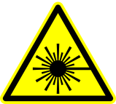

**LASER PRODUCT**

**LASER RADIATION – AVOID DIRECT EYE EXPOSURE**

**WAVELENGTH: 850nm**

**MAXIMUM OUTPUT POWER: Depends on drive mode**

User Guide

**Mocha Testing**

**Hardware Components:**

1. **1x 3D Camera Module (for use with USB 3.0 cable)**

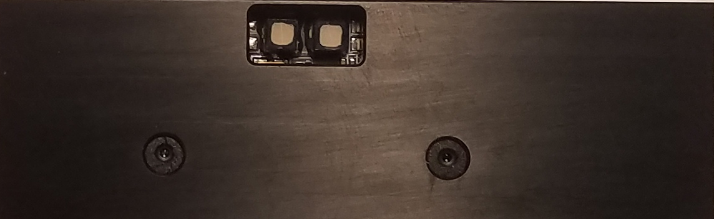 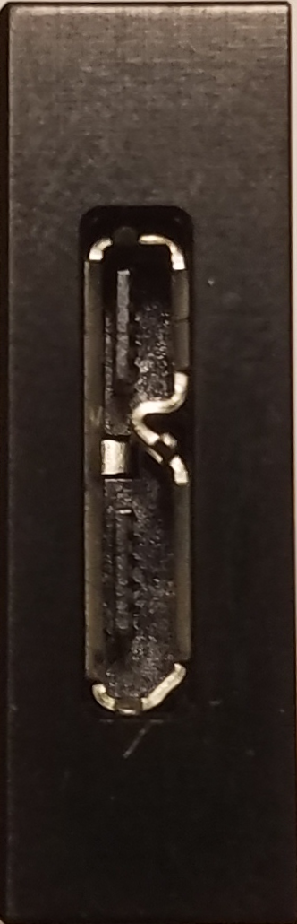

**Front view Right Side view (USB socket)**

1. **Stand Holder**

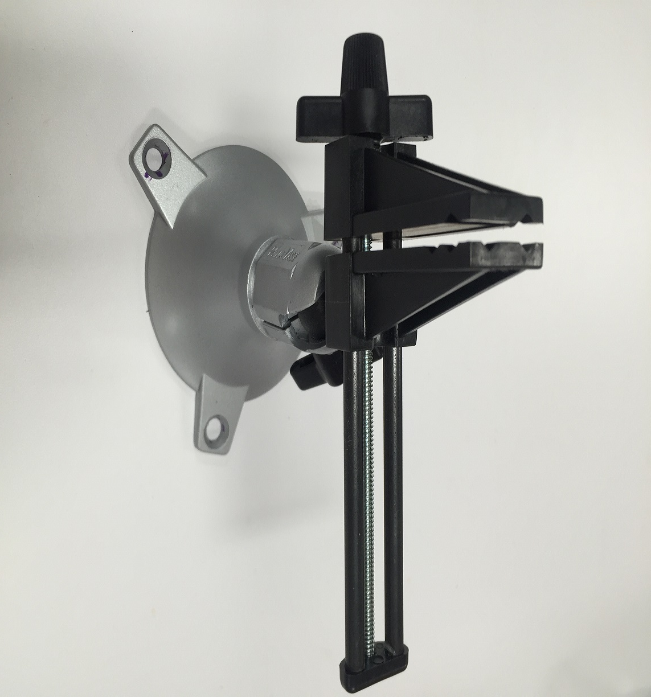

1. **2 x Boxes(non-reflective material surface, white color preferred)**

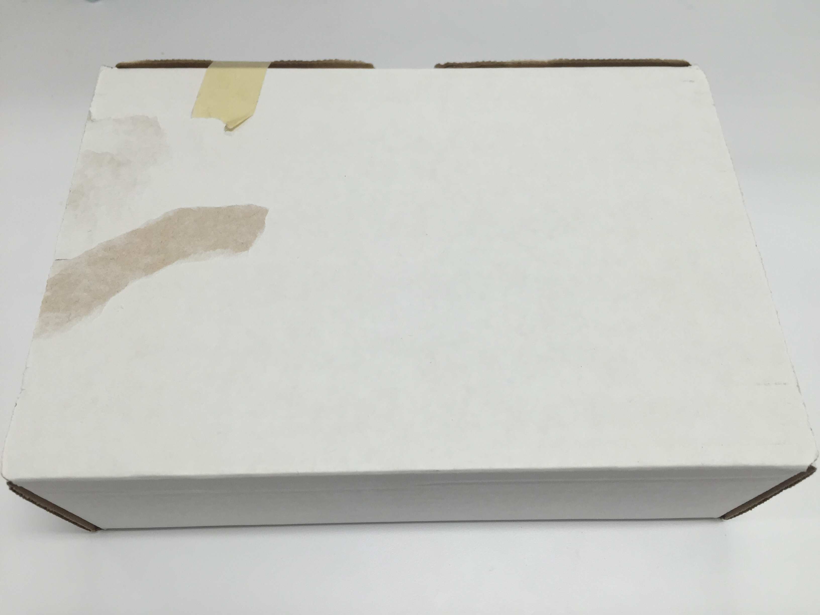

1. **Meter Measurement**

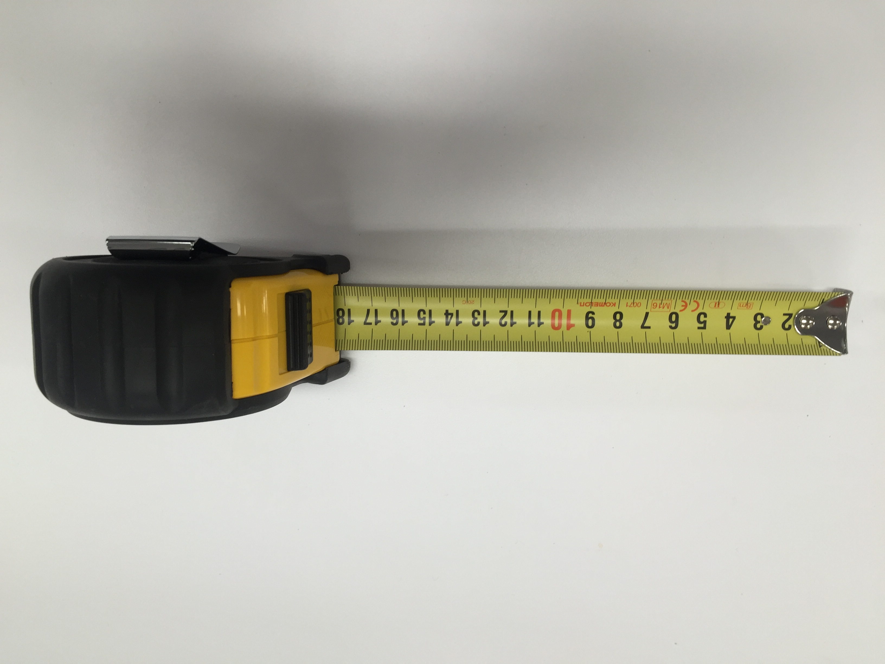

**Software Preparation**

General Introduction: The system is cross-platform developed and eventually will run on Windows, Android, Linux and OSX. However, the current testing user manual is based on windows application. Please ask for latest software before moving down.

**Environment Requirement**

The testing needs to be done in indoor environment with as little sunshine or infrared light as possible.

**[Setup]**

General Description: Use stand holder to hold Mocha. Two target object(non-reflective white boxes preferred) need to be set stand in front of camera within field of view. One is 50cm away and the other is 100cm away from the frontal surface of the boxes to Mocha itself. Please refer to the pictures as setup scene.

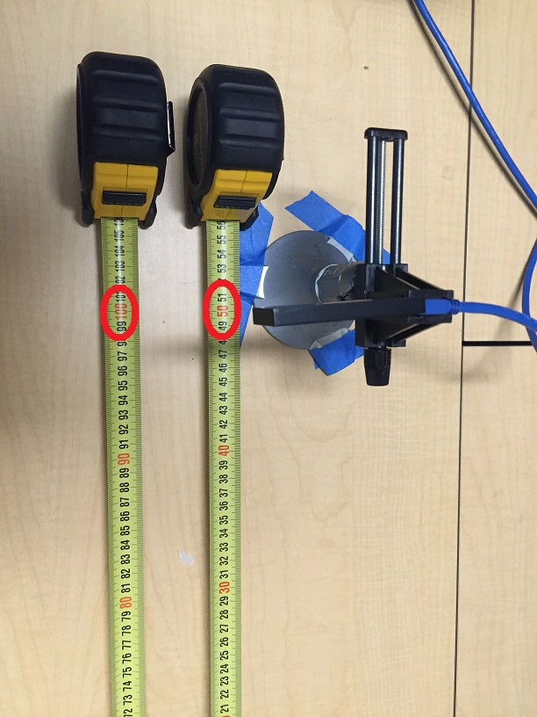

**Picture 1**

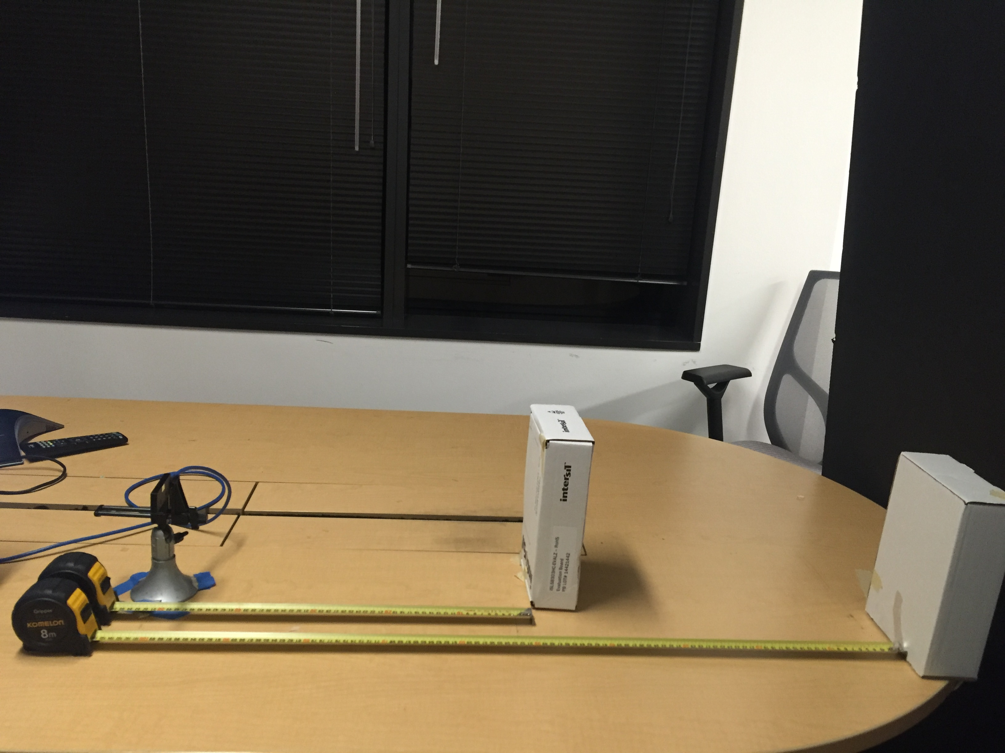

**Picture 2**

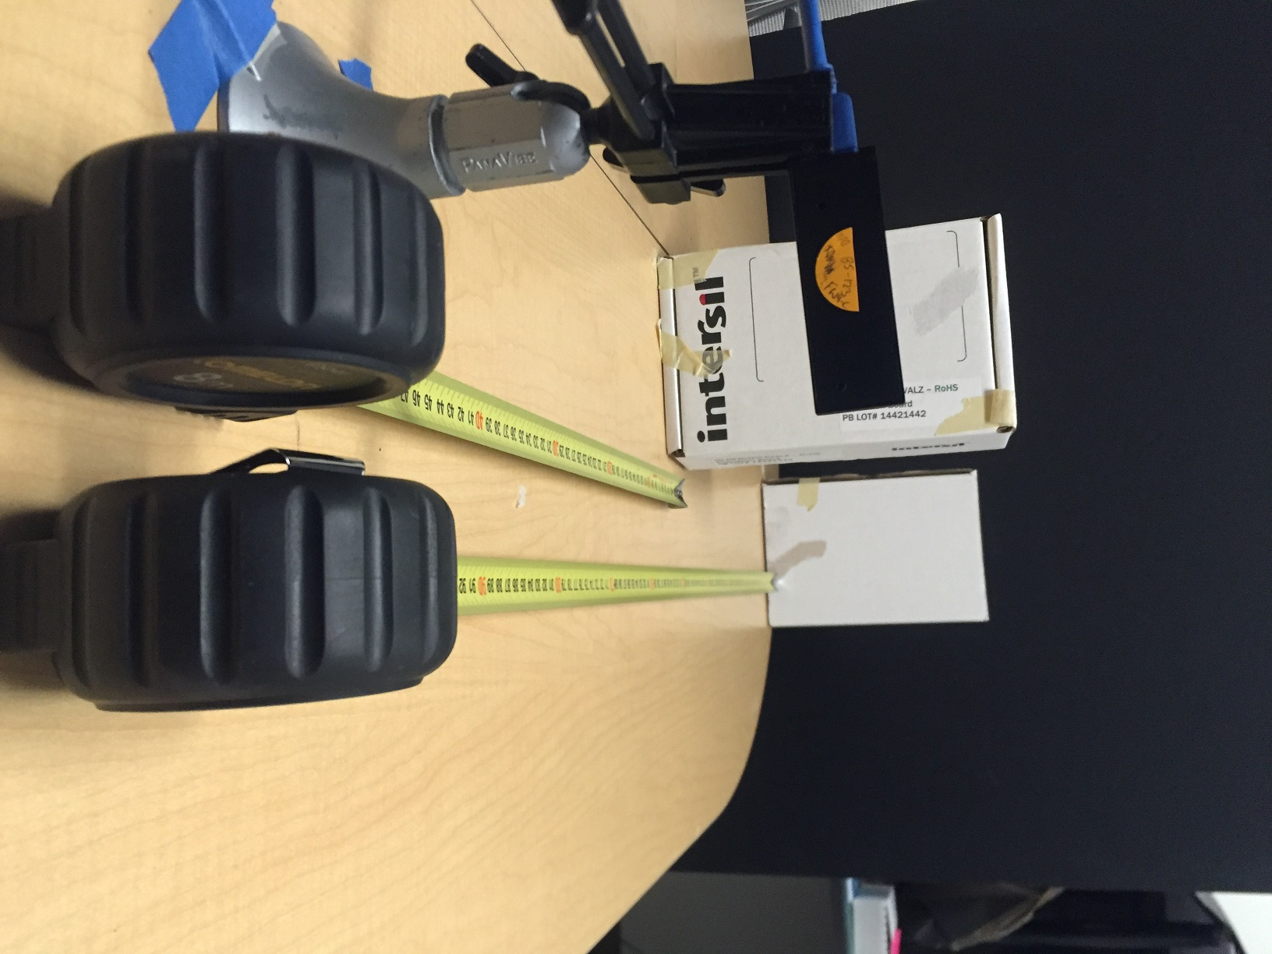

**Picture 3**

**PC: Windows 7/Windows 10**

**[SW Testing Guide]**

General Description: In general to pass the testing, based on the testing images, Dual Limas need to be confirmed to work well and calibration should be fine for **all three resolutions(wide angle FOV 640x360, VGA 640x480, QVGA 320x240)**. A special dual-lima pattern could be observed if dual Limas work well, disparity map should be clean and depth be accurate(error 3% for 50cm target and 6% for 100cm target) if calibration is done well. Please refer to the testing procedure as below:

1. Extract the software (folder name “app_timestamp_mocha(_xxx)”) onto the PC running Windows 7 or later
2. Connect the Mocha module via the USB cable that is provided
3. Open the extracted folder which includes two folders, named “build” and “resource”, and one batch file named “run.bat”.
4. Prepare a form to record testing result. The empty sample testing form is showed below:

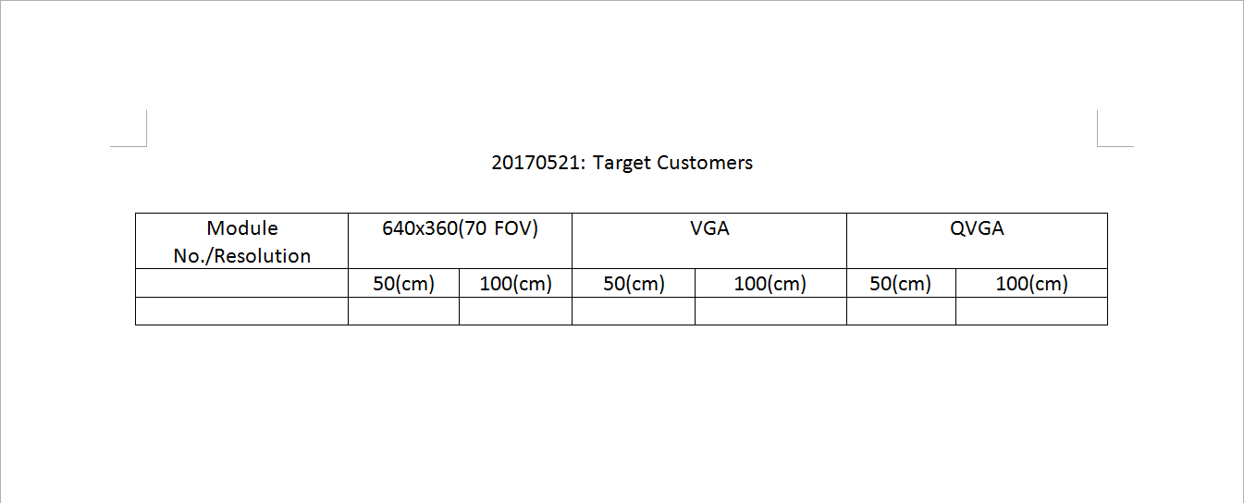

Empty Sample Testing Form

1. Once the cable is connected, right click and **Edit** run.bat with default editor.

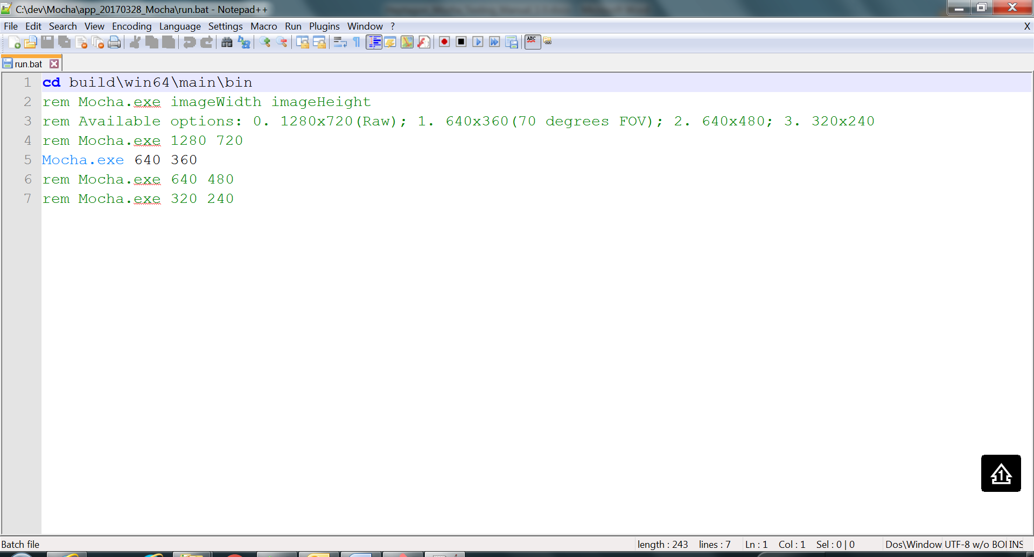

By default, **resolution for wide angle field of view 640x360** will be selected as default.

Double click on the “run.bat” file. A Dos window will pop up as shown below.  
It takes a few seconds to run the app on the Windows platform. If the Dos window shows the same as the screenshot below, then everything the module is ready for operation

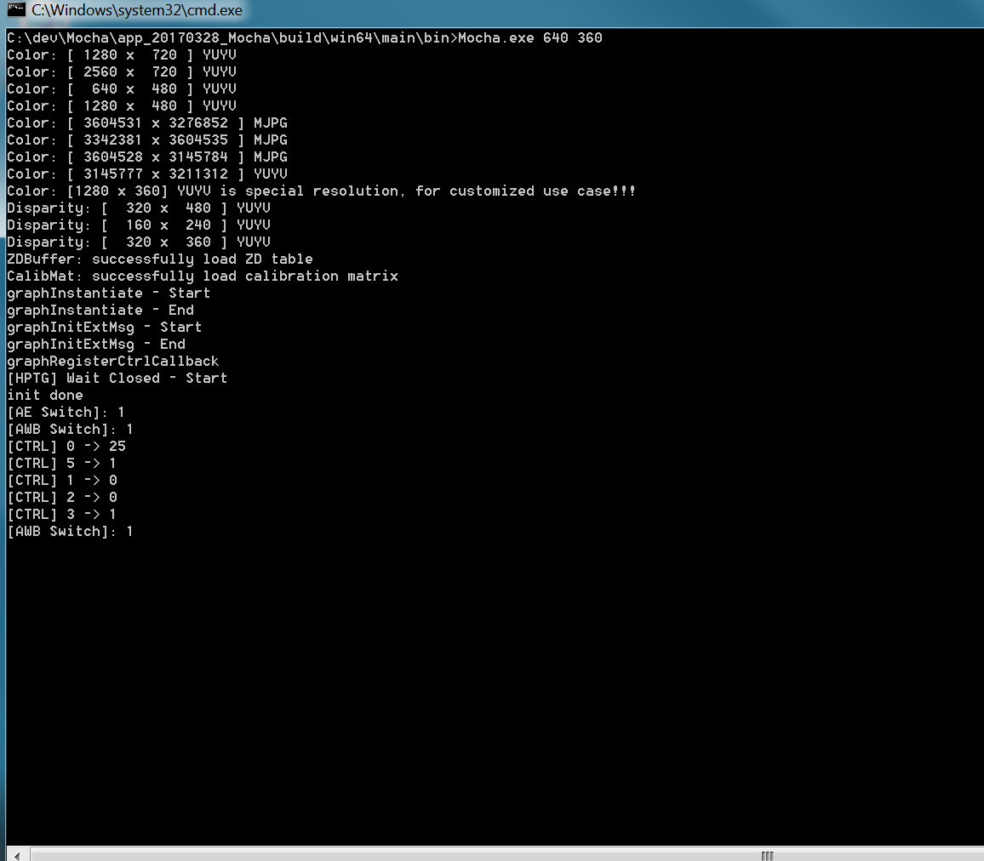

1. If the module is not connected or the USB connection is not good, then the following screenshot will appear.

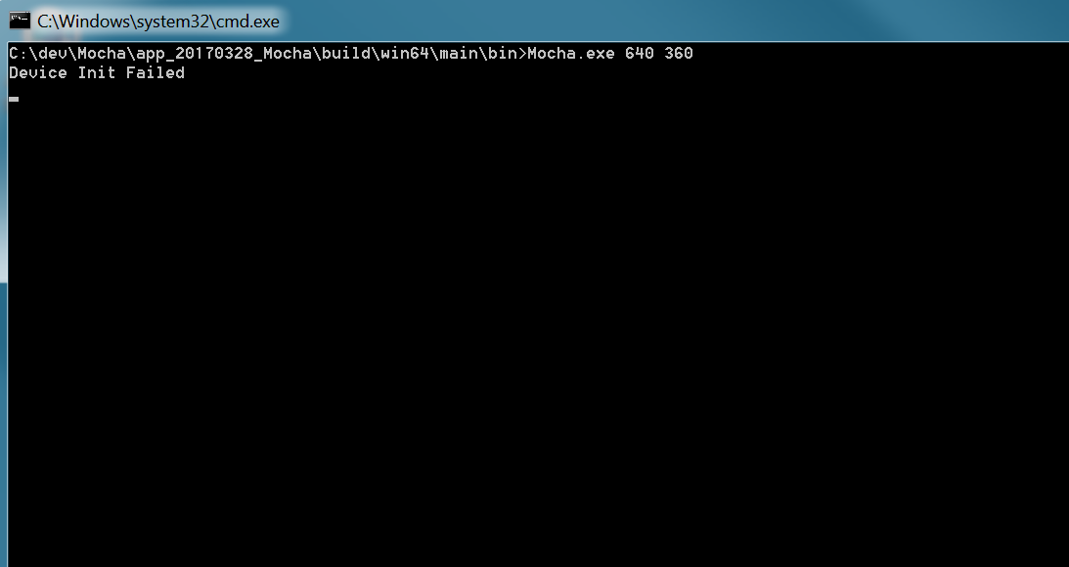

1. In that case close the DOS window, unplug module and plug it in again. Try running the BAT file again.
2. Upon successful start of the setup, Displayed on the screen are the color image, rectified grey-level images, disparity map, and depth map which is 16bits based grey-level image.
3. Check Dual-Lima Pattern: The dots pattern showed below is based on dual-lima pattern. If pattern is different from this, probably one or both of dual limas are not functional properly.

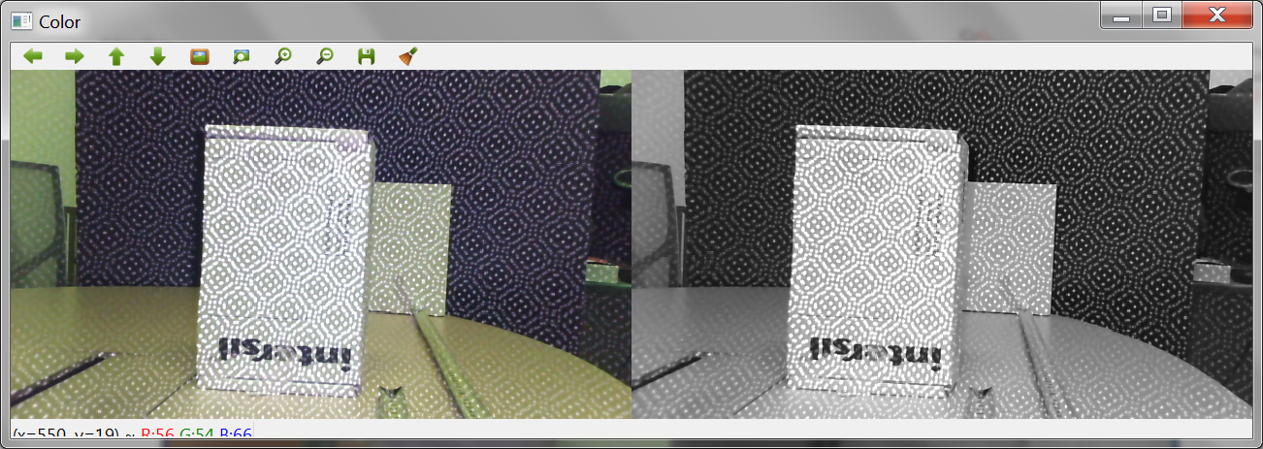

**Pair of Rectified Images**

1. Check Disparity Map Quality: The shown disparity map should be clean as below to indicate that calibration is not done or off. If a noisy disparity is seen, a recalibration for this resolution is needed to operate again.

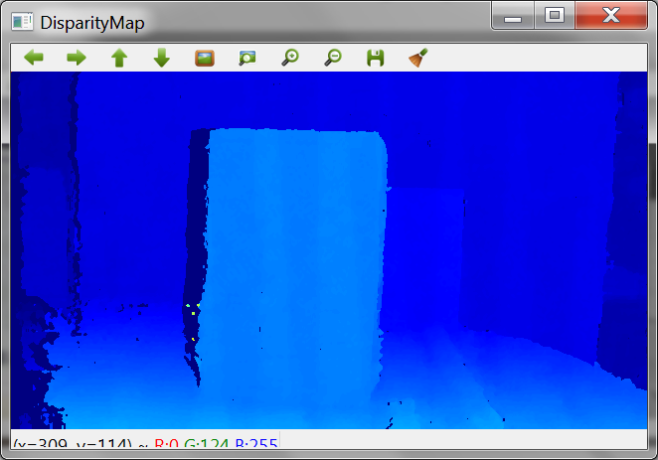

**Disparity Map**

1. Check Depth Map Accuracy: Left click on first target box, which is 50cm away from camera on reference image. A red dot is showed on the clicked location as below:

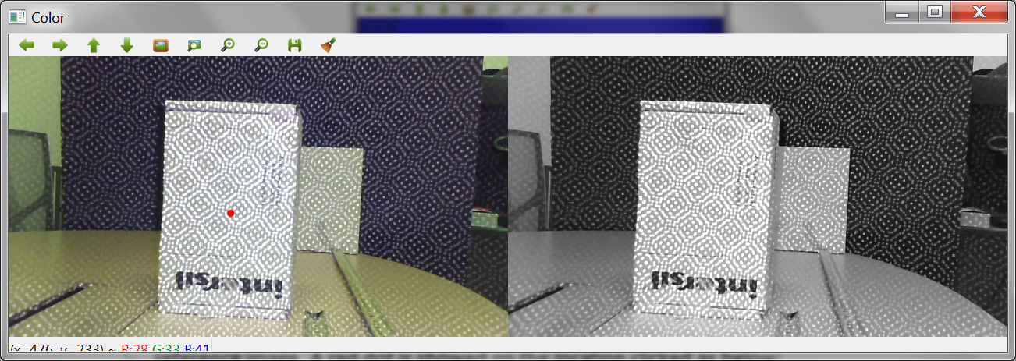

In the meanwhile, a new graph called “Depth Graph” is popped up accordingly.

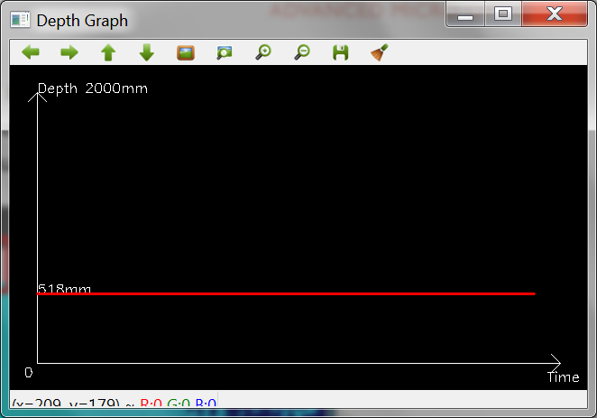

The distance in graph showed is in millimeter domain. Note down this number in the testing form and go ahead to look for the second target. Similarly, left click on the second target, which is 100cm away from the camera. A red dot is showed on the clicked location as below:

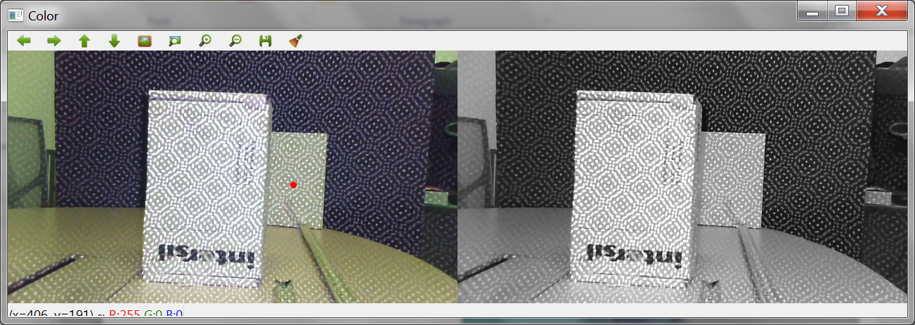

And “Depth Graph” is as below:

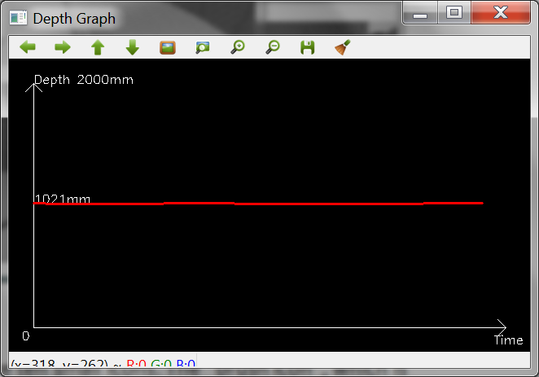

Note down this measurement number in the testing form. After the testing for this resolution, the testing form should be like shown below:

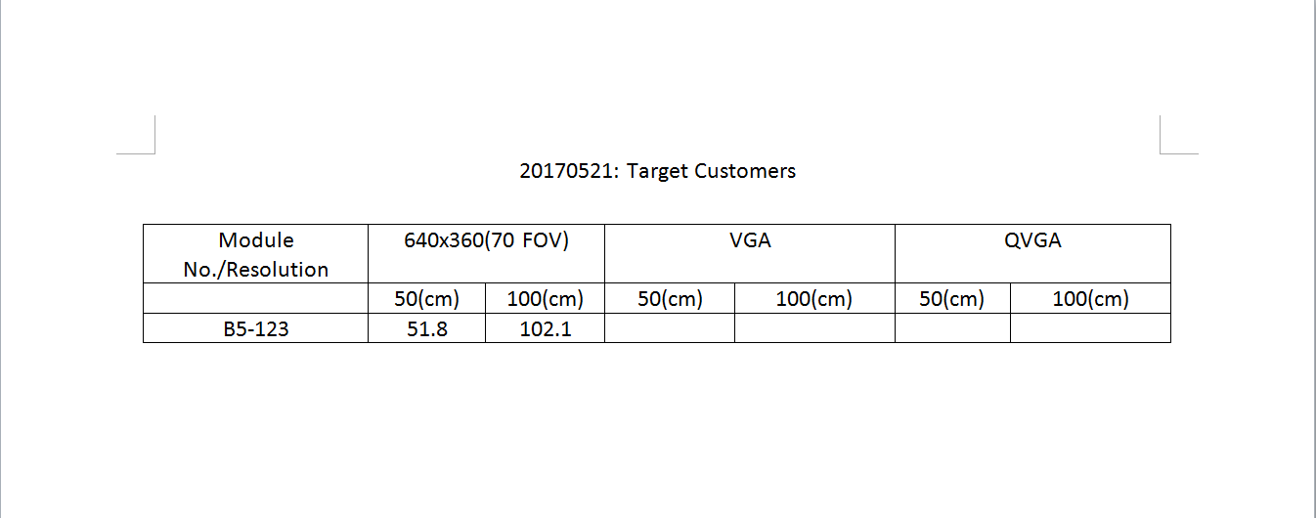

Sample Testing Form

1. Change resolution option in run.bat file as shown below, repeat step 4 – 10.

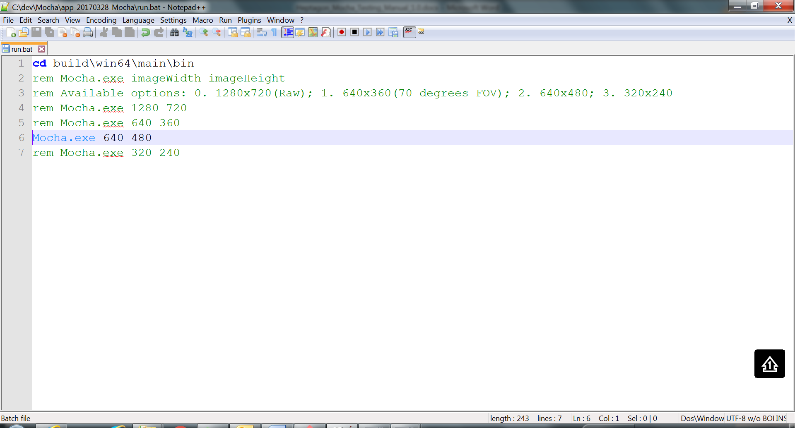

Revision History

|  |  |  |  |
| --- | --- | --- | --- |
| Version | By | Date | Notes |
| 1.0 | William Liu | 05/21/2017 | Preliminary version |

**HEPTAGON Product Disclaimer**

Heptagon Micro Optics Pte Ltd, its affiliates, agents, and employees, and all persons acting on its or their behalf (collectively, “Heptagon”), disclaims any and all liability for any errors, inaccuracies or incompleteness contained in any datasheet or in any other disclosure relating to any product.

Heptagon makes no warranty, representation or guarantee regarding the suitability of the products for any particular purpose or the continuing production of any product. To the maximum extent permitted by applicable law, Heptagon disclaims (i) any and all liability arising out of the application or use of any product and (ii) any and all implied warranties, including warranties of fitness for particular purpose, non-infringement and merchantability. IN NO EVENT SHALL HEPTAGON BE LIABLE FOR ANY DIRECT, INDIRECT, CONSEQUENTIAL, PUNITIVE, SPECIAL OR INCIDENTAL DAMAGES (INCLUDING, WITHOUT LIMITATION, DAMAGES FOR LOSS AND PROFITS, BUSINESS INTERRUPTION, OR LOSS OF INFORMATION) ARISING OUT OF THE USE OR INABILITY TO USE THIS DOCUMENT, EVEN IF HEPTAGON HAS BEEN ADVISED OF THE POSSIBILITY OF SUCH DAMAGES.

It is the customer’s responsibility to validate that a particular product with the properties described in the product specification is suitable for use in a particular application. Parameters provided in datasheets and/or specifications may vary in different applications and performance may vary over time. All operating parameters, including typical parameters, must be validated for each customer application by the customer’s technical experts.

Customers are solely responsible for compliance with all legal, regulatory and safety-related requirements concerning their products, notwithstanding any applications-related information or support that may be provided by Heptagon. Customers represent that they have all the necessary expertise to create and implement their own safeguards that anticipate dangerous failures, monitor failures and their consequences, lessen the likelihood of dangerous failures and take appropriate remedial actions.

Except as expressly indicated in writing, Heptagon’s products are not designed for use in medical, life- saving, or life-sustaining applications or for any other application in which the failure of the said products could result in personal injury or death. Customers using Heptagon’s products not expressly indicated for use in such applications do so at their own risk. Customers should obtain the latest relevant information before placing orders and should verify that such information is current and complete. Please contact authorized Heptagon personnel to obtain written terms and conditions regarding products designed for such applications.

No license, express or implied, by estoppel or otherwise, to any intellectual property rights is granted by this document or by any conduct of Heptagon. Heptagon reserves the right to make changes, without further notice, to any its products and accompanying supporting documentation.

Heptagon’s product specifications and datasheets do not expand or otherwise modify Heptagon’s terms and conditions of sale, including but not limited to any warranties expressed therein.

www.hptg.com

info@hptg.com

|  |  |  |
| --- | --- | --- |
| Heptagon Micro-Optics Pte Ltd  26 Woodlands Loop  Singapore 738317  Phone: +65 6483 6471  Fax: +65 6752 8583 | Heptagon Oy  Moosstrasse 2  CH-8803 Rueschlikon  Switzerland  Phone: +41 44 497 30 00  Fax: +41 44 497 30 01 | Heptagon USA, Inc.  3945 Freedom Circle, Suite 400  Santa Clara, CA 95054  USA  Phone: +1 650 336 7990 |